Visit Report: Indo-Pacific Young Leaders Program, Canada
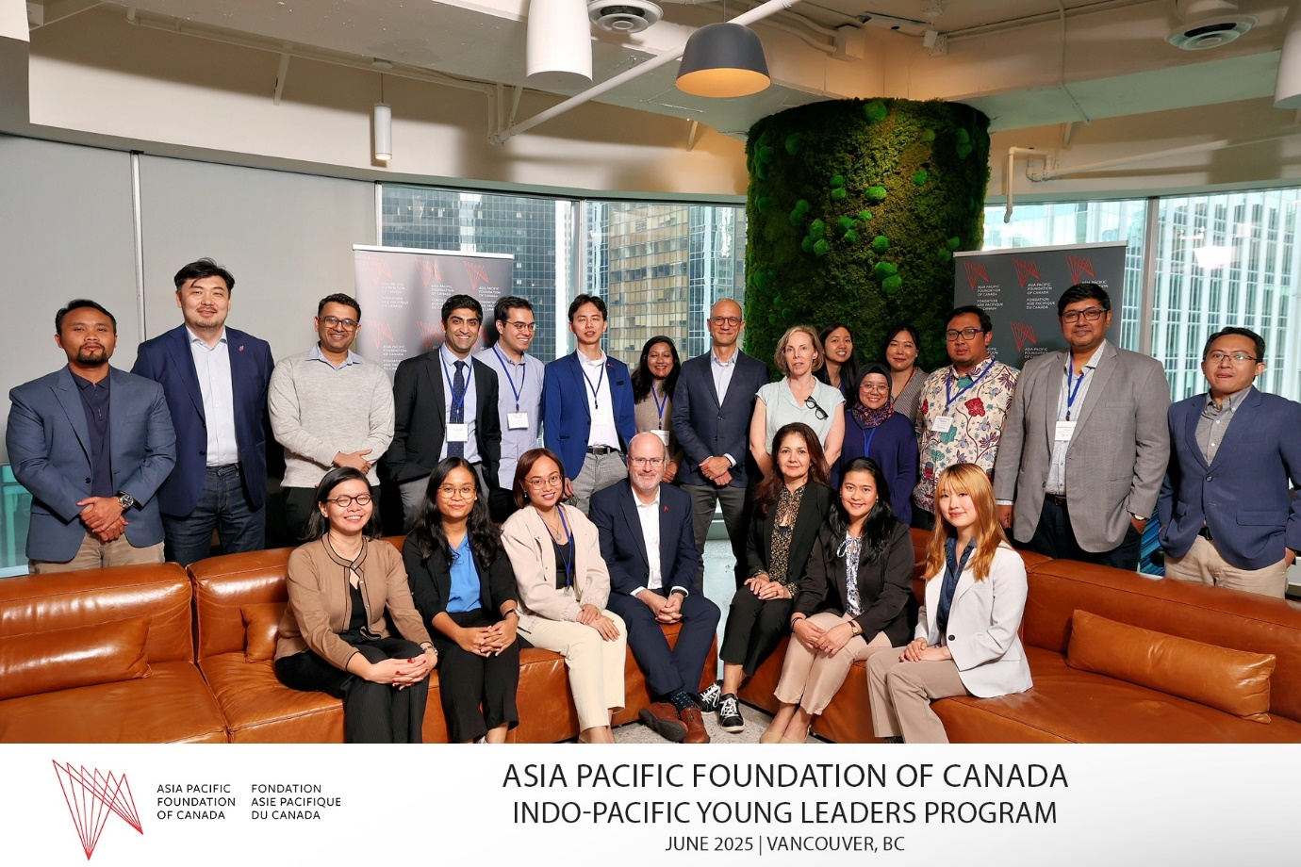

By A.S.M. Tarek Hassan Semul, Research Fellow, BIISS
June 8–14, 2025 | Montreal, Ottawa & Vancouver

A.S.M. Tarek Hassan Semul, Research Fellow at the Bangladesh Institute of International and Strategic Studies (BIISS), participated in the inaugural Indo-Pacific Young Leaders Program hosted by the Asia Pacific Foundation (APF) of Canada and funded by the Government of Canada. The weeklong immersion program brought together 15 emerging leaders from across the Indo-Pacific region to engage with Canadian policymakers, academics, and private sector representatives on contemporary issues shaping the Indo-Pacific agenda.
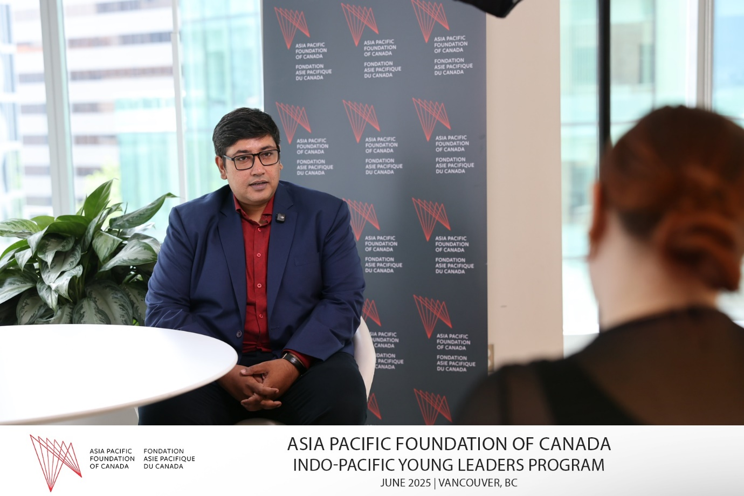
The program covered three major Canadian cities—Montreal, Ottawa, and Vancouver—and featured high-level dialogues on regional security, innovation, artificial intelligence, misinformation, energy security, and Canada’s Indo-Pacific strategy. Mr Semul presented on “Bangladesh’s Recent Political Transition and its Relation with the Geopolitical Environment in the Indo-Pacific Region” during a reception with francophone journalists and experts in Montreal.
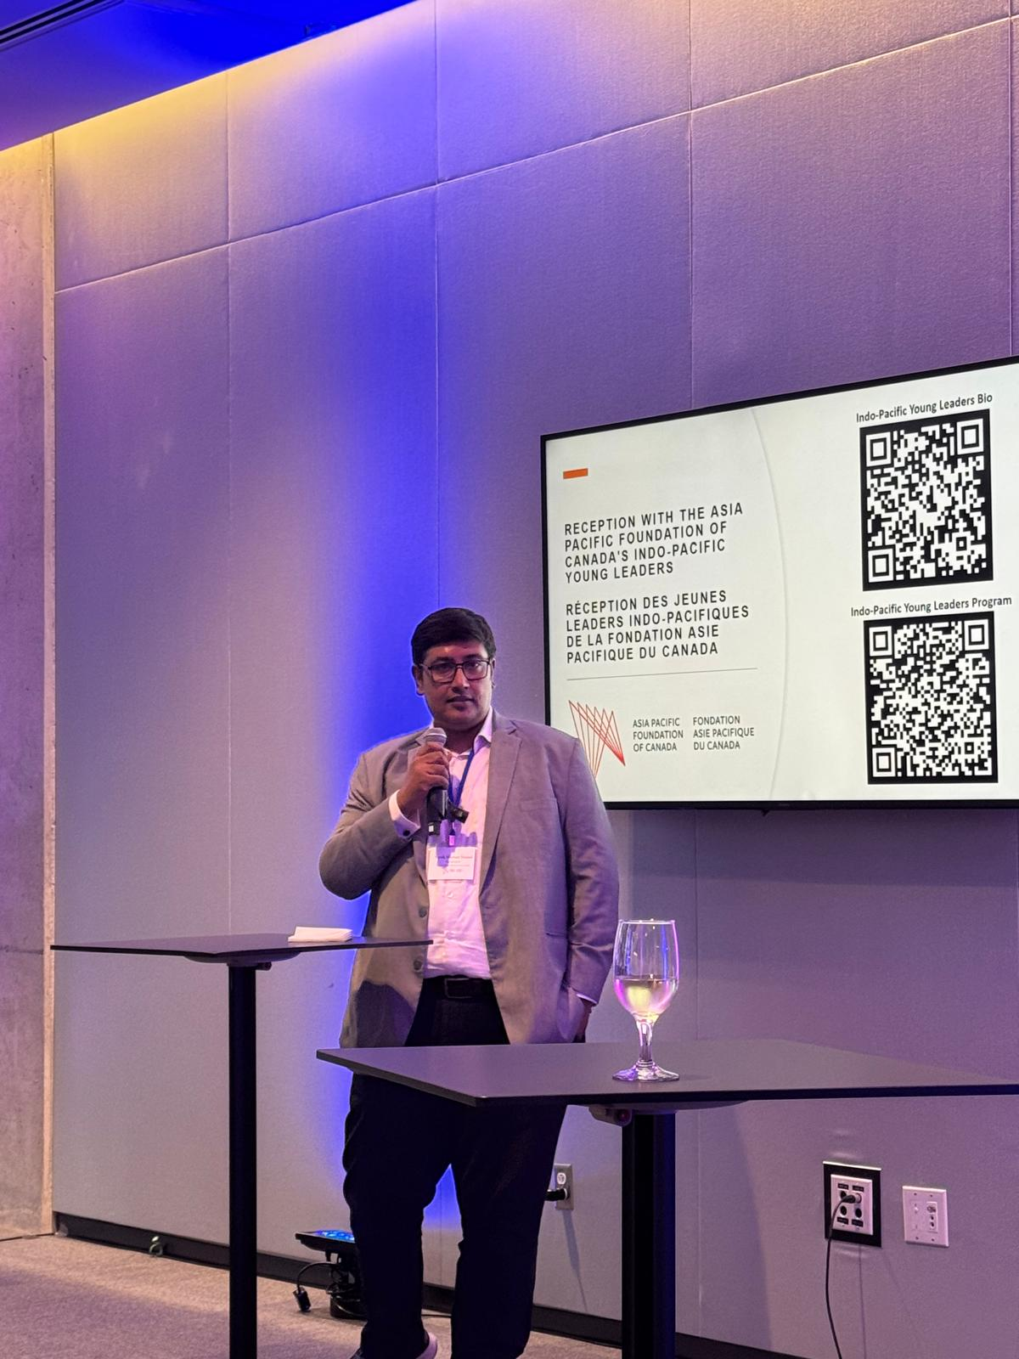
Engagements included discussions with the Institute for the Study of International Development at McGill University, Global Affairs Canada, the Department of National Defence, Natural Resources Canada, and the University of British Columbia’s Institute of Asian Research. The participants also interacted with experts from think tanks such as the Global Centre for Pluralism and the Montreal Institute for Global Security.
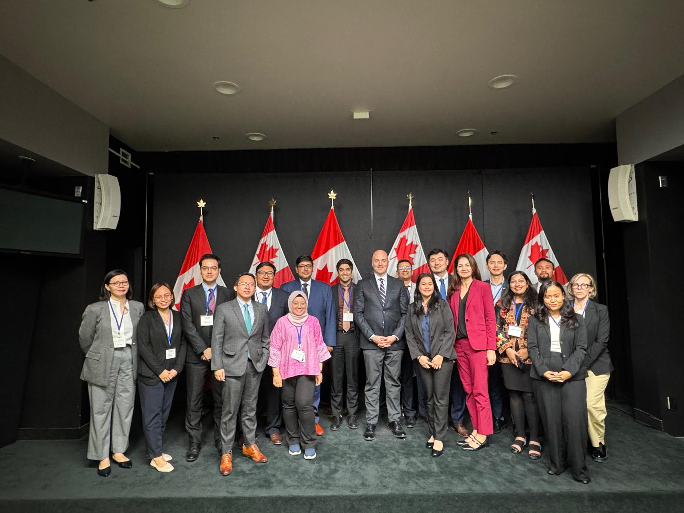
The visit provided valuable insights into Canada’s evolving Indo-Pacific engagement, its priorities under new leadership, and its efforts to balance liberal values with strategic realities. The experience contributed to a deeper understanding of Canada’s role as a middle power and its implications for Bangladesh’s foreign and defence policy choices in the Indo-Pacific. The program also strengthened BIISS’s institutional networks with Canadian policy and research communities.

