Global Cooperation at Crossroads: Key Highlights from WEF 2025
[4 February, 2025]
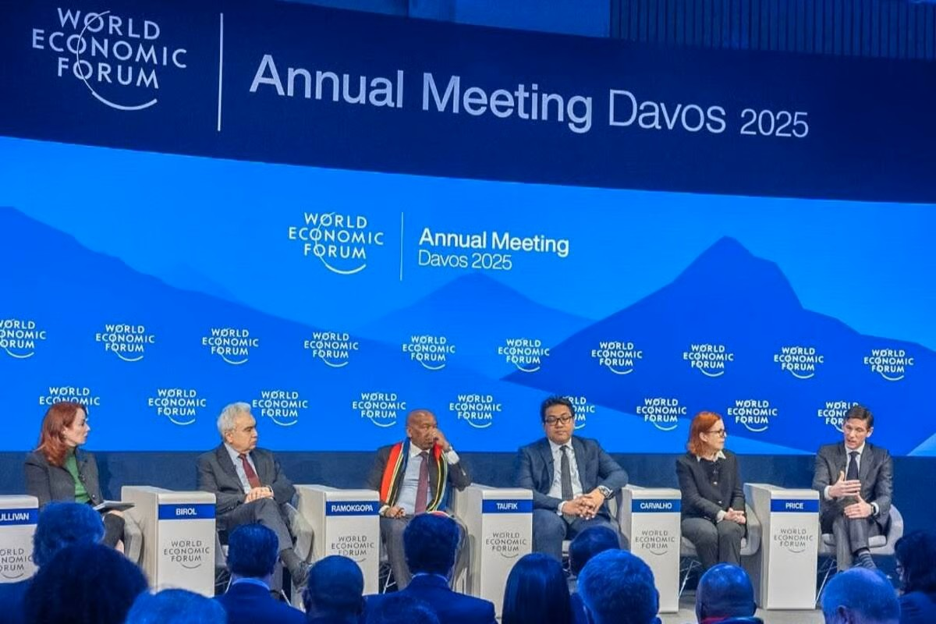
The 2025 World Economic Forum (WEF) Annual Meeting, held in Davos from January 20–24 under the theme “Collaboration for the Intelligent Age,” served as both a mirror and a testing ground for the state of global cooperation. While the gathering underscored the urgency of collective action in a world grappling with climate risks, technological disruption, and widening inequalities, it also revealed deep fractures in the multilateral system. At the heart of the forum were five priority areas: rebuilding trust, reimagining growth, safeguarding the planet, advancing industries in the intelligent age, and investing in people. Climate action and artificial intelligence (AI) dominated discussions. AI was framed not merely as an economic tool but as a transformative force capable of reshaping industries, enhancing efficiency, and addressing global challenges such as climate adaptation. Importantly, the WEF emphasized incremental milestones—rather than distant goals—as crucial for maintaining momentum toward net-zero commitments. Businesses, in particular, were urged to embed sustainability within their core operations, positioning corporate responsibility as a cornerstone of future governance.
Yet, geopolitics intruded sharply into the optimism. The return of Donald Trump to the White House reverberated throughout Davos, sparking anxieties over his protectionist trade policies, deregulatory agenda, and pro-fossil fuel stance. His remote participation—emphasizing isolationism and economic nationalism—signaled a reduced U.S. commitment to multilateral institutions. This rhetoric not only challenged global climate ambitions but also highlighted the growing divide between nationalist policy agendas and the demands of interdependence. Against this backdrop, the Global Cooperation Barometer 2025 offered a sobering assessment. While cooperation remains above pre-pandemic levels, overall progress has stagnated since 2020. The peace and security pillar has seen the steepest decline, weighed down by escalating conflicts and record displacement, while innovation and climate cooperation showed relative resilience. Trade fragmentation, unequal access to technology, and declining health cooperation painted a picture of uneven progress.
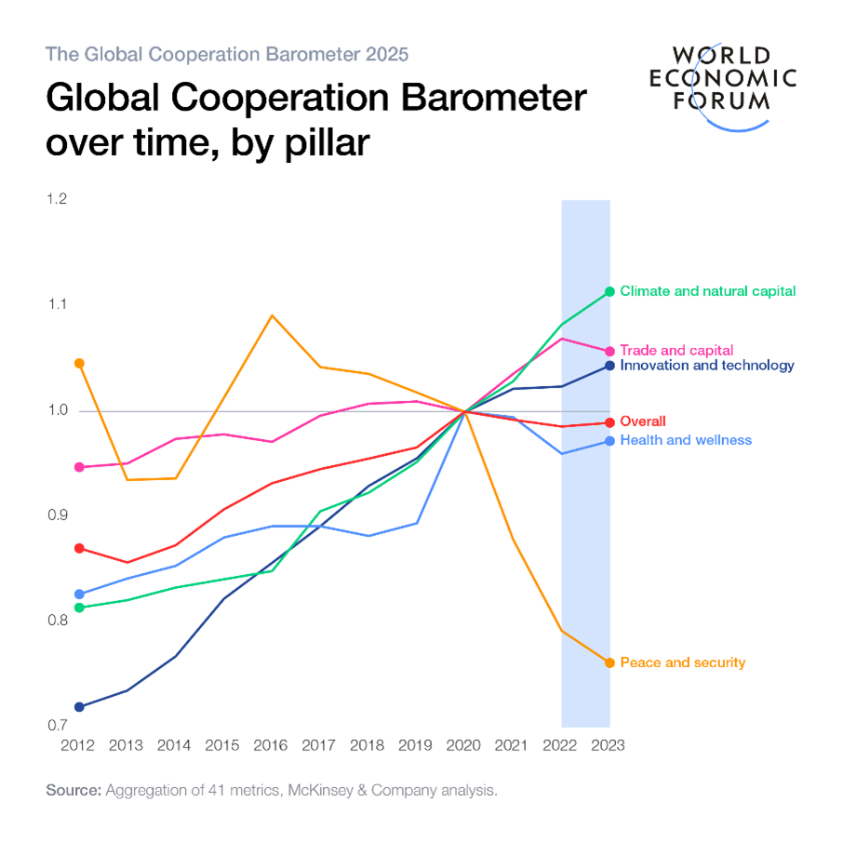
The challenges underscored at WEF 2025 reflect both systemic and structural obstacles. Nationalism, digital divides, geopolitical rivalries over critical minerals, and the absence of enforcement mechanisms for global commitments have all undermined trust in international institutions. The widening gap between developed and developing economies—particularly in climate finance and AI governance—further complicates consensus building. Nevertheless, the forum also highlighted pathways toward renewed cooperation. Calls for innovative and flexible partnerships were coupled with appeals for equitable trade policies and inclusive finance. Notably, Dr. Muhammad Yunus advocated for a global framework ensuring fair access to capital, especially for marginalized communities in the Global South, while stressing the transformative role of youth in shaping inclusive futures. His interventions reflected the need for systemic reforms that transcend short-term national interests.
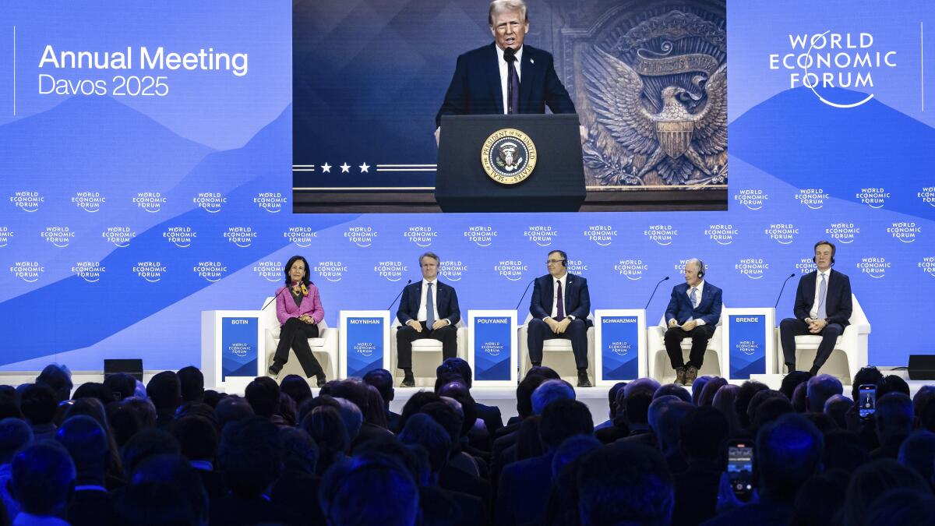
In conclusion, WEF 2025 reaffirmed the necessity of collective action in an era of fragmentation. Its vision of inclusive growth, sustainability, and strengthened multilateralism presents a compelling roadmap. Yet, the true test lies in implementation: moving from rhetoric to meaningful cooperation that bridges divides and ensures resilience. The crossroads at which global cooperation stands today will determine whether the promises of the “intelligent age” are realized or squandered in a tide of polarization.

Understanding the Global Consequences of USAID’s Suspension
[19 February 2025]
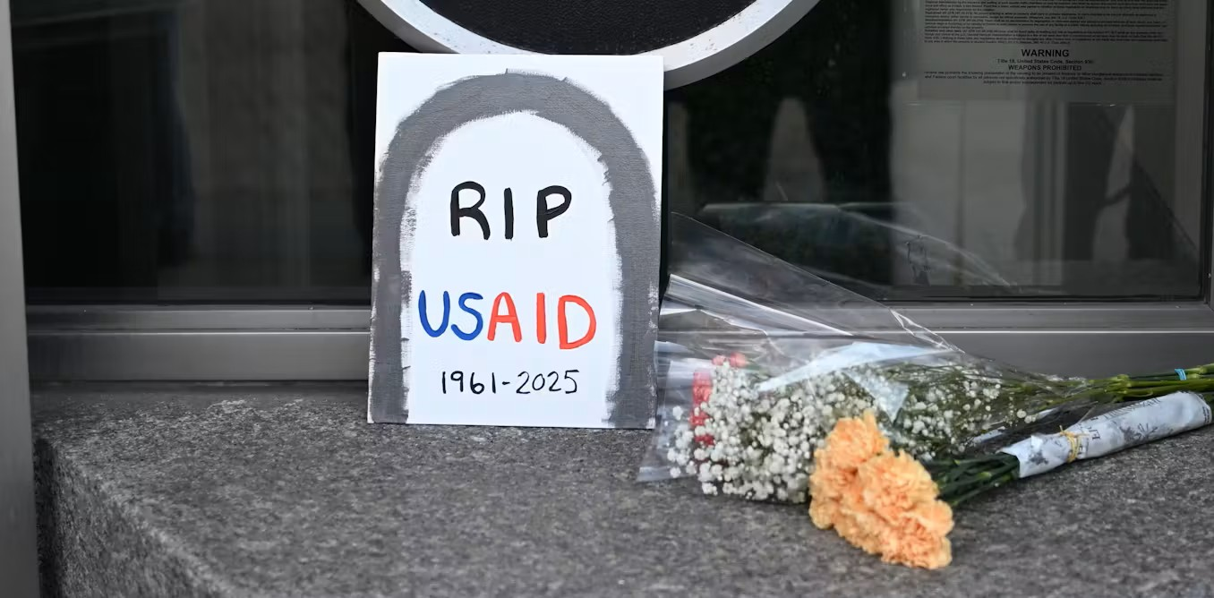
The abrupt suspension of the United States Agency for International Development (USAID) in early 2025 has triggered far-reaching implications for global development and stability. As one of the largest foreign aid agencies, USAID has historically served as a critical pillar of humanitarian relief, governance reform, and sustainable growth in over 100 countries. Its sudden withdrawal under the Trump administration not only destabilizes ongoing aid programs but also reshapes the geopolitical landscape.
From a humanitarian perspective, the suspension endangers millions of vulnerable populations who depend on USAID-funded food assistance, disaster relief, and refugee support. Programs addressing acute crises in regions like Syria, Yemen, and sub-Saharan Africa risk collapse, exacerbating food insecurity and prolonging displacement. Equally concerning is the disruption of public health initiatives, including vaccination drives, HIV/AIDS treatment, and maternal health services. For low-income countries that rely heavily on donor-funded healthcare, the halt in funding threatens to reverse decades of progress in immunization and disease control. The economic fallout is similarly acute. USAID’s grants and concessional loans have long bolstered small businesses, agricultural development, and infrastructure projects in fragile economies. The suspension withdraws a lifeline for entrepreneurs and workers, undermining local growth and widening inequalities. More broadly, trade networks and supply chains tied to USAID projects—particularly in agriculture—may experience significant setbacks, compounding global economic fragility.
Diplomatically, the suspension weakens U.S. soft power. For decades, USAID has been instrumental in projecting American influence by fostering goodwill and embedding democratic values abroad. Its absence risks creating a vacuum that rivals such as China and Russia are poised to fill. Through initiatives like the Belt and Road, Beijing is likely to expand its footprint in Africa, Asia, and Latin America, offering alternative development financing with fewer political conditions. This shift may erode Washington’s credibility as a reliable partner and accelerate the reconfiguration of global alliances. The environmental and social dimensions further illustrate the magnitude of the consequences. USAID’s suspension halts renewable energy, reforestation, and climate adaptation programs vital for communities facing rising sea levels and extreme weather. Civil society organizations—often dependent on USAID support—are left weakened, undermining democratic resilience and accountability in fragile states. Educational programs are also jeopardized, threatening literacy and school access for millions of children. Collectively, these setbacks risk deepening global inequality and stalling progress on the Sustainable Development Goals (SDGs).
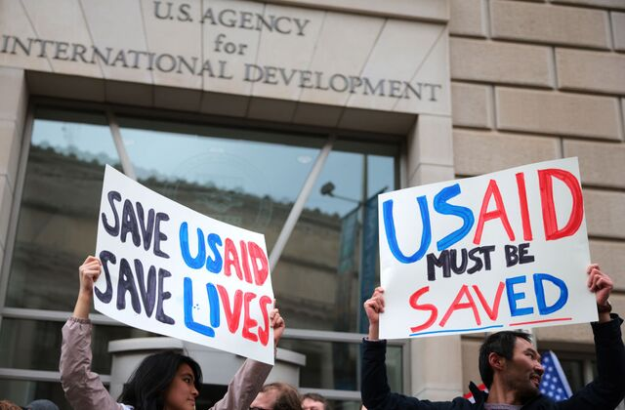
Bangladesh exemplifies the localized but severe consequences of this decision. As a long-standing recipient of U.S. assistance, Bangladesh faces disruptions across public health, climate resilience, and economic growth. Most pressing is the Rohingya refugee crisis: USAID has been the largest donor supporting nearly one million refugees in Cox’s Bazar. The withdrawal of funding could escalate humanitarian distress, straining Bangladesh’s limited resources and testing its social stability. In conclusion, while the suspension of USAID exposes inefficiencies and longstanding criticisms of the aid system, its abrupt nature magnifies vulnerabilities across the globe. The long-term consequence is a potential reordering of international development finance, with U.S. influence diminished and rival powers gaining leverage. For aid-dependent nations, this crisis underscores the urgency of diversifying funding sources, strengthening domestic resource mobilization, and forging regional cooperation. Ultimately, the suspension marks not just a disruption in aid but a pivotal moment in the geopolitics of development.

